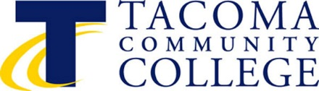

TACOMA COMMUNITY COLLEGE

BOARD OF TRUSTEES

6501 South 19th Street BOARD STRATEGIC PLANNING SESSION (VISION)
Tacoma, WA 98466 Tuesday, March 26, 2019
2:00 pm – 4:00 p.m.
Board Room, Building 12

SPECIAL MEETING OF THE BOARD OF TRUSTEES
March 26, 2019

AGENDA

I. CALL TO ORDER James Curtis

II. BOARD STRATEGIC PLANNING SESSION (VISION) James Curtis

III. REMARKS

IV. ADJOURNMENT James Curtis

Interpreters for people with hearing impairments and Braille or taped information for people with impairments can be provided. Please contact Angelique Odom, Office of the President at 6501 South 19th St., Tacoma WA 98466; Tel: 253/566-5136; Telephone Device for the Deaf TDD 253/566-5169; or e-mail: aodom@tacomacc.edu.

