2022-23 STATE SUPPORT AND STUDENT COSTS FOR WASHINGTON STATE COMMUNITY AND TECHNICAL COLLEGES

The average cost to educate a resident full-time community or technical college student for the 2022-23 academic year is $15,023. Students pay an average of $3,527 in tuition toward this cost. The remaining $11,496 is an “opportunity pathway” provided by the State and is funded by state taxes and other sources. The amounts shown are averages for a full-time, resident student. The actual tuition a student pays will vary due to credit load, residency status and other factors.

Amounts in the table below represent an average for a full-time equivalent, lower division resident student attending community and technical colleges for the academic year 2022-23.
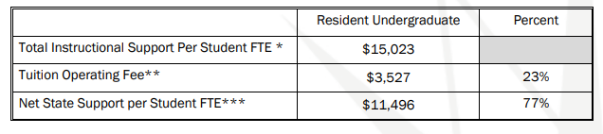
*Total Instructional Support is composed of Tuition Operating Fee and Net State Support
**The Tuition Operating Fee is equal to the operating fee for a full-time student in lower division classes.
***Net State Support is the amount paid by the state from various sources including taxes and other funds.

Source: Washington State Board for Community and Technical Colleges (SBCTC) November 2022

