→ Go to ctcLink Gateway Login Page:  https://gateway.ctclink.us  At the bottom right:  → Click First Time User? | 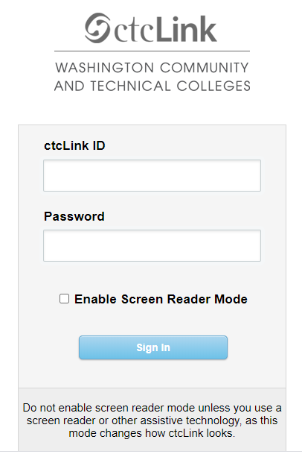 ←
→ Enter First Name, Last Name, and Date of Birth  → Select ctcLink ID (new)  → Hit Submit | 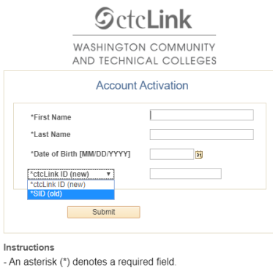
→ Set up your Security Questions  → Set up a password  IMPORTANT: After clicking Submit on this page, a popup window appears and it will show your CtcLinkID.  Please write down your CtcLink ID and Password!  You will need this ID number to log in, it is your Student Number at Tacoma Community College | 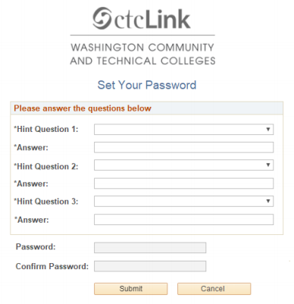
Finally, after copying your ctcLink ID number, click OK. | 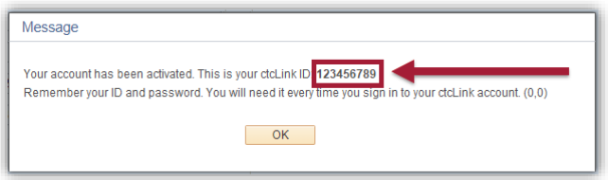
That’s it! You’ve activated your ctcLink account. Now let’s log in to ctcLink for the first time! And Remember,
Please write down your CtcLink ID and Password!

You will need this ID number to log in, it is your Student Number at Tacoma Community College

